New Illinois Laws 2020: Health, Human Services

Review the new laws that will take effect on Jan. 1, 2020.

By Lorraine Swanson, Patch Staff

Dec 30, 2019 1:15 am CT | Updated Dec 30, 2019 1:28 am CT
Reply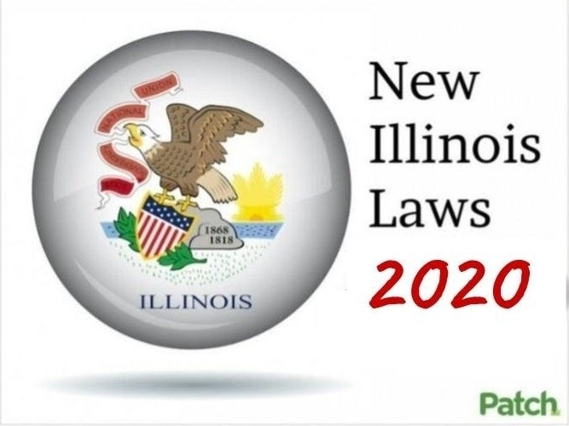Review the new Illinois laws that will take effect Jan. 1, 2020. (Patch Graphic)
Pregnancy and Childbirth Rights (HB 2) - Amends the Medical Patient Rights Act to delineate 21 rights of women during pregnancy and childbirth
Authorized Electronic Monitoring (HB 344) - Creates the Authorized Electronic Monitoring in Community-Integrated Living Arrangements and Developmental Disability Facilities Act by authorizing the use of video or audio surveillance in a resident's room at the resident's own expense.
Amends the Electronic Fund Transfer Act (HB 465) - Establishes regulations for Pharmacy Benefits Managers that operate in Illinois.
Child Abuse Reports-DPH-DHFS (HB 831) - If DCFS gets a report of suspected abuse or neglect of a child who was receiving care in a hospital, including psychiatric hospitals, DCFS shall notify the Directors of DPH and HFS of the report. DPH licenses those facilities, HFS provides healthcare for those patients under Medicaid.
Insurance Code-Tick-Borne Disease Coverage HB 889) - Requires health insurers to cover long-term antibiotic therapy for people with a tick-borne disease.
Subscribe
Juvenile Court-Family Support Program (HB 1551) - Requires DCFS to accept a report as a child welfare services referral when a report is made by a mandated reporter and there is a prior indicated report of abuse or neglect and a prior open service case involving any member of the household.
Service Member-Expedited Licensure (HB 1652) - The Department of Financial and Professional Regulations (IDFPR) must designate one staff member as the Department's military liaison to ensure licensure requirements for service members' and their spouses are managed properly and efficiently.
Prisonor-Juvenile Justice Medical/Dental Co-Payments (HB 2045) - Prohibits the Department of Corrections and the Department of Juvenile Justice from requiring a committed person to pay any co-pay for receiving medical or dental services.
Health in All Policies Act (HB 2146) - Requires UIC School of Public Health and IDPH to convene a working group to come up with policy recommendations relating to the health of Illinois residents.
Children and Youth Adult Mental Health Crisis Act (HB 2154) - Creates the Children and Youth Adult Mental Health Crisis Act, which will restructure the Individual Care Grant/Family Support Program for children and young adults with high mental health need regardless of type of insurance coverage.
Family Mental Health Centers (HB 2247) - Creates a community-based pilot program for persons with mental illness or persons at risk for mental health diagnosis in communities with high need or underutilization of mental health services.
Blood Pressure-Pregnancy (HB 2433) - Requires every hospital to ensure it has the proper instruments available for taking a pregnant woman's blood pressure and requires the Department of Public Health to adopt rules to implement the requirement.
Medical-Minor's Consent (HB 2665) - Allows a minor of 12 years of age or older to give consent for health care services or counseling related to the prevention, rather than only for diagnosis and treatment, of sexually transmitted diseases.
Law Enforcement Wellness and Suicide Prevention (HB 2767) - Requires the IL Law Enforcement Training & Standards Board to create, develop, or approve an inservice course addressing issues of officer wellness and suicide prevention.
IDPH-Hemorrhage Training (HB 2895) - Requires hospitals caring for pregnant and postpartum women to train for related medical issues and implicit bias training. DPH must support statewide perinatal quality improvement initiative, reduce racial and ethnic disparities.
Diversity in Health Care Professions Task Force (HB 2896) - Creates the Diversity in Health Care Professions Task Force, and provides objectives and priorities, requires it to prepare a report for the Governor and the General Assembly by December 1, 2020 and annually thereafter.
Maternal Mental Health-IDPH Federal Funding (HB 2897) - Requires DPH to investigate and apply for federal funding opportunities to support maternal mental health and requires DPH to file a report with the General Assembly on or before January 1, 2021 about its efforts. Sunset: 1/1/2022.
Medicaid Redeterminations (HB 3040) - Amends the Public Aid Code to require that if an individual has transferred from one long-term care (LTC) facility to another LTC facility, the individual Medicaid eligibility must be sent to the LTC facility where the individual resides and to that individual.
DHS-Long-Term Care Notice (HB 3039) - Amends the Public Aid Code and requires the Department of Human Services (DHS) to send notice of terminated Medicaid assistance to the long-term care facility where the resident resides, in addition to notifying the resident.
Probate-Assault of Elderly (HB 347) - Adds other actions to the definition of abuse against the elderly. These acts include assault, aggravated assault, battery, and aggravated battery.
Community-Integrated Living (HB 3069) - Requires any facility licensed under the Community-Integrated Living Arrangements Licensure and Certification Act to notify the Department of Human Services when emergency calls are made from the facility.
Physicians Pharmaceutical Education Program (HB 3097) - Requires the Department of Healthcare and Family Services to develop a pharmaceutical education program for prescribing physicians under Medicaid.
Parkinson's Disease Public Awareness (HB 3247) - Creates the Parkinson's Disease Public Awareness and Education Program to promote public awareness of Parkinson's disease and the value of early detection and possible treatments and sets forth requirements for the program.
Mental Health and Developmental Disabilities Code-Sex Education (HB 3299) - Requires that individuals admitted to developmental disability facilities and receiving habilitation shall have access to sex education, related resources, and treatment planning that supports their rights to sexual health and freedom from sexual exploitation and abuse.
Housing Grants To Homeless (HB 3331) - Changes to the types of assistance offered to households to prevent homelessness by adding the payment of rent or mortgage to the types of assistance available.
Higher Education-Mental Health Information (HB 3404) - Requires public colleges and universities to provide information to students on all mental health and suicide prevention resources available at the university.
Health Care-Closed Captioning (HB 3468) - Requires all health care facilities to make reasonable efforts to have the closed captioning feature on a television activated at all times in a common area provided for use by the general public or in a patient's room.
Coverage Cardiopulmonary Monitor-Minor (HB 3471) - Requires insurance companies to provide coverage for cardiopulmonary monitors for minors.
Human Breast Milk Coverage (HB 3509) - Requires certain health insurance companies to cover donated human breast milk for infants under the age of up to 12 months or older if deemed medically necessary.
Maternal Mental Health Coverage (HB 3511) - Directs the Department of Human Services to develop educational materials for health care professionals and patients about maternal mental health conditions.
Equitable Restroom-Baby Changing Stations (HB 3711 ) - Requires all public restrooms in a public building to have a baby changing facility.
Mandatory Coverage-Diagnostic Mammograms (SB 162) - Mandates insurers to cover diagnostic mammograms and makes changes to the coverage mandate for comprehensive ultrasound screening.
Estate-Health Directives (SB 182) - Requires the Department of Public Health to study the feasibility of creating a statewide registry of advance directives.
Mental-Physical Health Instruction (SB 459) - Requires the instruction on mental health and illness included within the State of Illinois' Comprehensive Health Education Program to evaluate the multiple dimensions of health by reviewing the relationship between physical and mental health to promote health, well-being and human dignity.
IDPH-Phlebotomy-Training (SB 1214) - Requires the Department of Public Health to make training materials available to ensure those who draw blood from individuals with intellectual and developmental disabilities are trained in the most current method of drawing blood.
Dense Breast Tissue Act (SB 1506) - Providers of mammography services must notify patients of dense breast tissue and recommend follow-up testing in a mammography report if a patient's mammogram demonstrates dense breast tissue.
Apprentice Stipends for DCFS Youth (SB 1525) - Requires DCFS to provide eligible youth with an apprenticeship stipend to cover the costs associated with entering and sustaining through an apprenticeship.
Sudden Infant Death Autopsies (SB 1568 ) - Changes when coroners are required to preform autopsies on children aged 2 years or younger who die suddenly to 1 year or younger.
Advanced Practice Psychiatric Nurse (SB 1702) - Allows advanced practice psychiatric nurses to complete certificates for commitment and authorize restraint and seclusion for patients.
Pharmacy Practice-Injections (SB 1715) - Allows pharmacists to administer mental health drugs to patients via injection.
Alzheimer Advisory Committee (SB 1726) - Creates the full-time position, Dementia Coordinator, within the Department of Public Health to oversee the implementation of the Illinois Alzheimer's Disease State Plan.
DCFS Survey-Foster Children (SB 1743) - Requires DCFS to develop and implement a feedback survey for foster children who have aged or are aging out of the program.
Parolee-Medicaid Screening (SB 1744) - Requires the Department of Corrections (DOC) to screen inmates prior to release for Medicaid eligibility.
Child Abuse Training-Mandated Reporters (SB 1778) - Reorganizes the list of individuals who are required to immediately report to the Department of Children and Family Services when they have reasonable cause to believe that a child may be abused or neglected. Also requires training for mandated reporters.
Alzheimer-Behavior Risk Factor (SB 1909) - Requires funds from the Alzheimer's Disease Research, Care and Support Fund that are not used for expenses of the Dementia Coordinator to be used for the Behavioral Risk Factor Surveillance System and for implementing activities outlined in the Alzheimer's Disease State Plan.
Communal Kitchens (SB 2068) - Prohibits a public health district from regulating serving food in private residential household.
Customized Employment for Individuals with Disabilities Act (SB 2087) - Creates a five-year pilot program for finding employment for individuals with disabilities, tasked with helping them find jobs and negotiating fair wages.
Source: Illinois State Democrats
Like Thank Reply

